1. In the previous week, we learned about different commands to create the file with different file extensions.
   1. In the desktop create the batch file name it **pingdomain**.bat

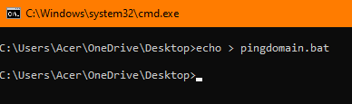

* 1. In that particular batch file, write the script to ping the server by taking a user input.

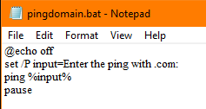

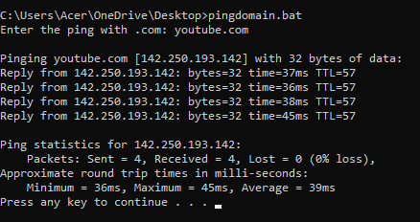

1. Create a batch file Nepal.bat, write the batch script to create a txt file having text: *I am learning batch file in week-10*. 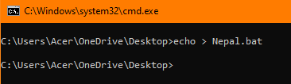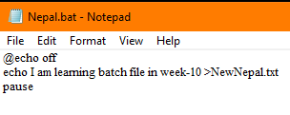

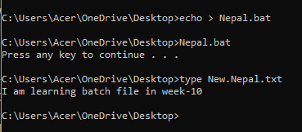

1. Create the batch file to show the system information in the text file info.

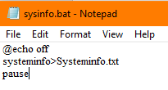

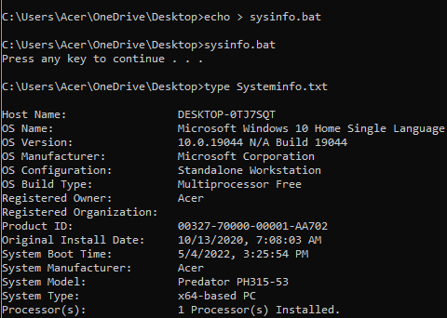

1. 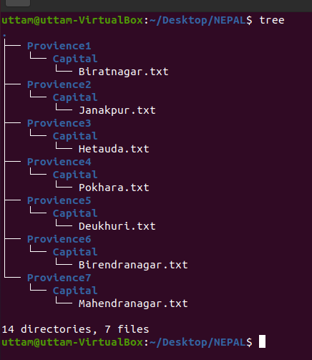Create the batch file which contains the command to create the below diagram.

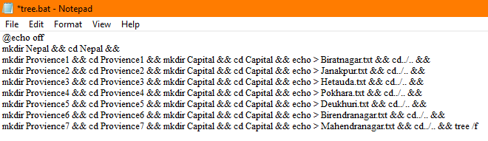

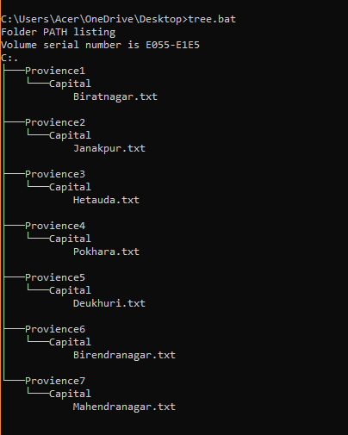

1. Create a batch script that automatically backs up your documents folder.

Note: create a backup folder in the desktop and copy the contents of documents into that folder and use windows task scheduler.

